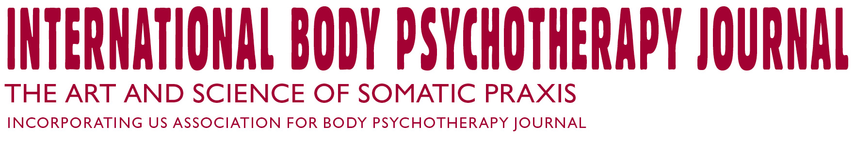

Sponsorship Form

I would like to sponsor the:

International Body Psychotherapy Journal
The Art and Science of Somatic Praxis

(Tick which one you would like)
- Individual sponsorship – € 150 per year
For body psychotherapy professionals, researchers, educators and scientists

- Institutional sponsorship – € 295 per year
For training institutes, professional associations, universities, research/educational institutes

- Corporate sponsorship – € 500 per year
For industries, companies & corporations

Full Name (in block letters):

Nationality:

Affiliation:

Professional Interest:

Mailing Address:

City:

Country:

Email:

Phone (Home):
(Mobile:
(Work):

PAYMENT DETAILS

Membership Cost: ____________ (Including all taxes) In words: ______________________________________________________

Payment details:
Bank transfer to: ING Bank, Financial Plaza, Postbus 1800, 1000 BV Amsterdam, The Netherlands
Account name: European Association for Body-Psychotherapy
Swiftcode: INGBNL2A IBAN number: NL83INGB0009392200

Credit Card Payment: We accept American Express credit cards.

